Data flow diagram(DFD) for Ecommerce website
A data flow diagram is a graphical view of how data is processed in a system in terms of input and output.
The Data flow diagram (DFD) contains some symbol for drawing the data flow diagram.
Data flow diagram symbol
Symbol | Description
 | Data Flow – Data flow are pipelines through the packets of information flow.
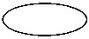 | Process : A Process or task performed by the system.
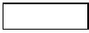 | Entity : Entity are object of the system. A source or destination data of a system.
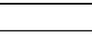 | Data Store : A place where data to be stored.

Context level DFD – 0 level
The context level data flow diagram (dfd) is describe the whole system. The (o) level dfd describe the all user module who operate the system. Below data flow diagram of online shopping site shows the two user can operate the system Admin and Member user.
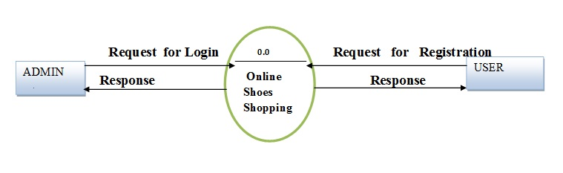o – Level DFD for Online shopping website project

1st Level Admin Side DFD
The Admin side DFD describe the functionality of Admin, Admin is a owner of the website. Admin can first add category of item and then add items by category wise. and admin can manage order and payment detail.
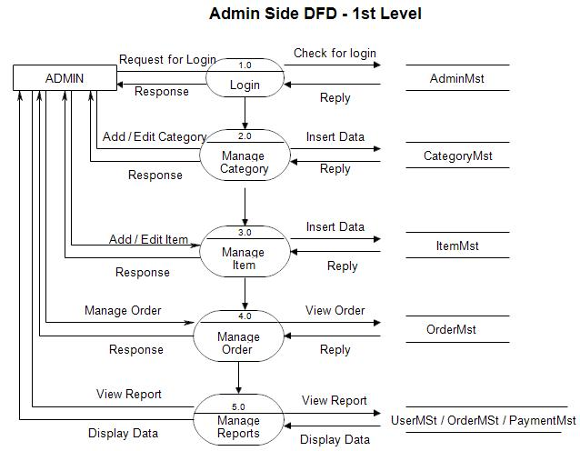1st Level – Admin Side Data Flow Diagram

2nd Level – Admin side DFD (3.0)
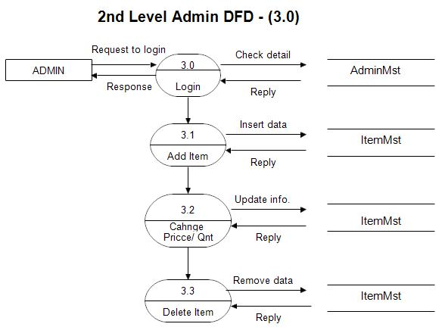DFD for online shopping website project

2nd Level – Admin side DFD (4.0)

